

**CSE6224 Software Requirement ENG**

**Project Part 1**

**Task 3: Requirements Elicitation Plan Using the Kano Model**

**Title: Campus Event Check-in System (CECS)**

**Prepared By:**

| **Student Name** | **Student ID** | **Email** | **Phone Number** |
| --- | --- | --- | --- |
| ERIC TEOH WEI XIANG | 1221102007 | 1221102007@student.mmu.edu.my | 017-406 3708 |
| PANG TIAN YOU | 1231303394 | 1231303394@student.mmu.edu.my | 011-10943832 |
| SIOW YI LING | 1211107982 | 1211107982@student.mmu.edu.my | 011-10923772 |
| LIM KAI SHEN | 1211110602 | 1211110602@student.mmu.edu.my | 012-2153379 |

## 

# **Table of Contents**

Table of Contents 2

1 Introduction to the Kano Model 3

2 Elicitation Method - Prototype Development 4

2.1 Planning & Requirements Refinement 5

2.2 Wireframing 5

2.3 High-Fidelity Prototype 5

2.4 Stakeholder Review and Feedback 6

2.5 Final Prototype Refinement 6

2.6 Prepare Demonstration / Video Walkthrough 6

3 Elicitation Method - Questionnaire 7

3.1 Target Audience 7

3.1.1 Students 7

3.1.2 Administrators 8

3.2 Process (Who, What, Where, When, Why, How) 8

3.2.1 Students 8

3.2.2 Administrators 8

3.3 Mapping Requirements to Kano Categories (Plan) 9

3.4 Sample Questions 12

3.4.1 Choose Admin or Student 12

3.4.2 Student Sample Questions 12

3.4.3 Admin Sample Questions 15

3.5 Expected Outputs from Questionnaire 17

3.5.1 Categorized User Requirements 17

3.5.2 Stakeholder-specific Needs 17

4 Kano Model Application & Analysis Methodology 18

4.1 Kano Model Categories 18

4.2 Analysis Methodology 19

5 Timeline and Milestones 20

6 Expected Outputs Summary 21

# 

# **1 Introduction to the Kano Model**

The Kano Model, developed by Professor Noriaki Kano, is a valuable tool for understanding and prioritizing software features based on user satisfaction and expectations. It categorizes requirements into three main types: Dissatisfiers, Satisfiers, and Delighters. For our Campus Event Check-in System with Student ID and Payment Integration, this model helps guide development by identifying which features are essential, which improve user experience, and which create unexpected delight.

Based on the Kano analysis shown in the figure, our system’s features have been classified as follows:

* **Dissatisfiers (Must-Have Requirements):**
  + These are fundamental features that users expect by default.
  + Their absence leads to dissatisfaction, even though their presence may not increase satisfaction significantly.
  + Examples include: Login, Register for Event, Create and Manage Event, Generate QR Code, Check-in via QR, View Event List, Make Online or Onsite Payment, Generate Payment Report.
* **Satisfiers (Performance Requirements):**
  + These features increase satisfaction proportionally to how well they are implemented.
  + Users explicitly desire these functionalities and expect them to work efficiently.
  + Examples include: Track Attendance, Handle Refund Requests, View Payment Receipt, View Attendance Analytics, View Ratings/Feedback, Rate Event, Receive Notifications, Request Refund.
* **Delighters (Excitement Requirements):**
  + These are unexpected features that delight users when present but do not cause dissatisfaction if missing. They often add innovation and user engagement.
  + Examples include: Check-In Heatmap, Event Attendance Rewards, Friend Participation Visibility, Event Calendar Sync, Shared Event with Friends, Auto Close Registration.

# **2 Elicitation Method - Prototype Development**

**User:**

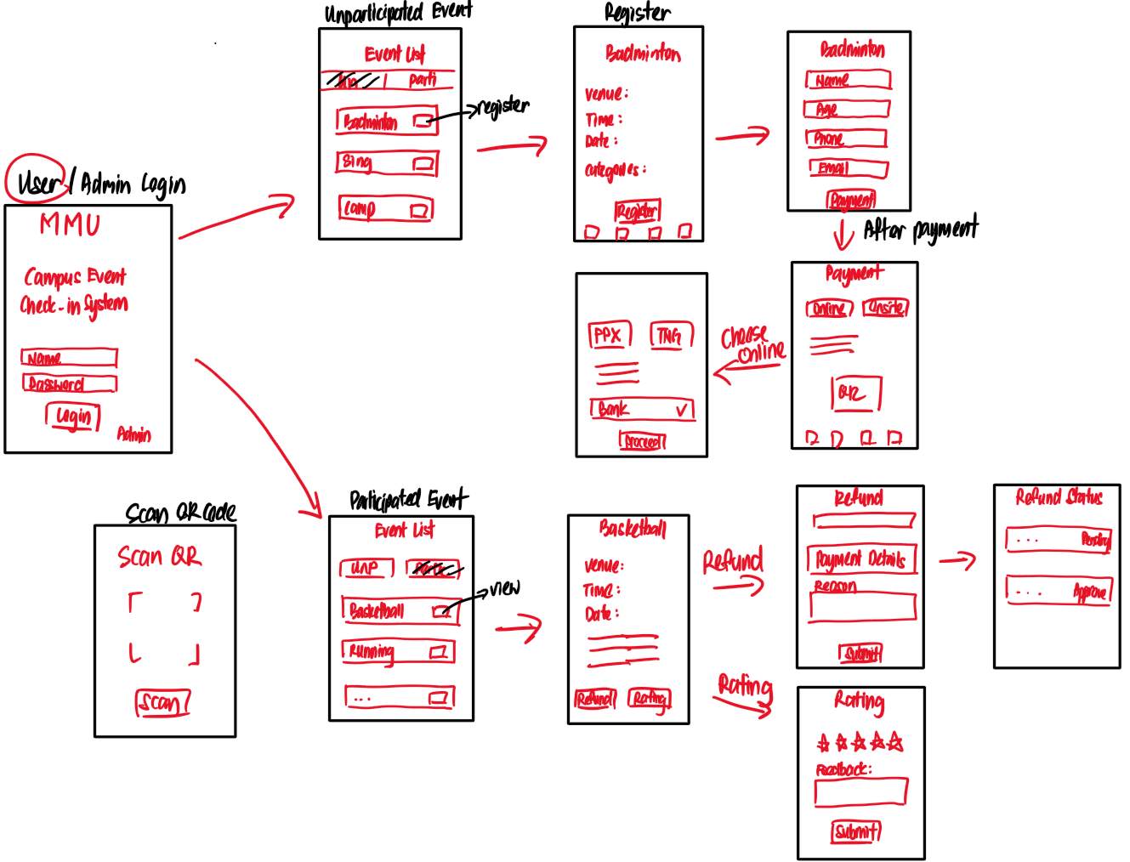

**Figure 2.1 : User Prototype Plan**

**Admin:**

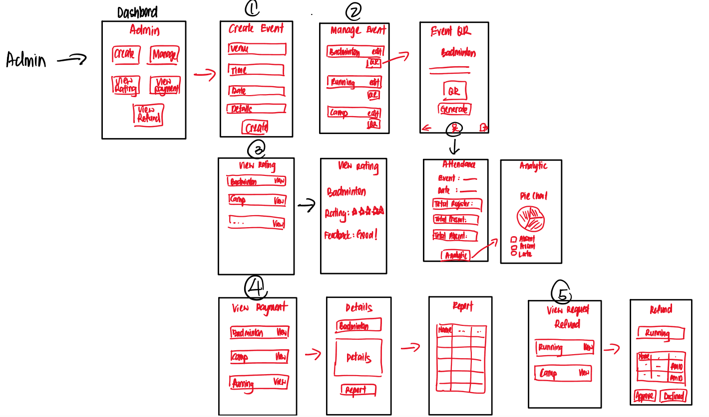

**Figure 2.2 : Admin Prototype Plan**

## **2.1 Planning & Requirements Refinement**

The first phase, Planning & Requirements Refinement, will take about 2–3 days. During this time, we’ll focus on identifying and prioritizing the key features needed for the system, ensuring the MVP includes all essential functionality such as login, event list viewing, registration, payment processing, and check-in. Once the features are finalized, they’ll be broken down into individual pages or screens based on the structure outlined in the preliminary plan. By the end of this phase, we’ll deliver a prioritized feature list, user stories, and flow maps for different user types, such as students and admins.

## **2.2 Wireframing**

The second phase, we expect will span 2 to 3 days and focus on creating low-fidelity wireframes for the system. Using tools like Figma, Adobe XD, or Balsamiq, we’ll design wireframes for all key pages and interactions. This includes the login pages for both users and admins, event list pages for participated and un-participated events, an event details page, a registration form, and payment pages for onsite and online transactions. Additional wireframes will cover the QR scan page, refund request and status pages, and the admin dashboard with management features like event creation, QR code generation, attendance tracking, and payment viewing. By the end of this phase, we’ll deliver a complete set of wireframes that map out all major user interactions.

## **2.3 High-Fidelity Prototype**

The third phase will take 4 to 5 days and involves transforming the wireframes into interactive, high-fidelity mockups. These prototypes will include realistic content and data placeholders to provide a more accurate representation of the final product. The mockups will feature click-through interactions to simulate key processes such as event registration and form submission, payment selection and flow, refund requests and approvals, and various admin functions like event editing, QR code generation, analytics, and payment tracking. The deliverable for this phase will be a fully interactive prototype, either shared via a Figma link or exported to a PDF with an interaction map for easy navigation.

## **2.4 Stakeholder Review and Feedback**

In this phase, we estimated it will take around 1 to 2 days to collect the review and feedback from the stakeholder. The high-fidelity prototype will be shared with group members, peers, or a supervisor to gather constructive feedback. The focus will be on identifying areas for improvement. By the end of this phase, we’ll compile a summary of stakeholder feedback and document a list of suggested revisions for refining the prototype.

## **2.5 Final Prototype Refinement**

During this phase, we estimate that it will take 2 to 3 days to refine our final prototype. This phase will apply the improvements identified in the stakeholder review to ensure that the prototype is perfect and ready for submission. Key tasks include refining the design based on feedback, maintaining consistency in UI elements (such as the share icon in the bottom bar), and preparing the final presentation version. The final deliverable will be a complete and final prototype package that can be shared via a Figma link, exported as a PDF, or formatted as a presentation.

## **2.6 Prepare Demonstration / Video Walkthrough**

During this part of the project, we're looking at about 2 to 3 days to fine-tune our final prototype. We'll take the feedback from the stakeholder review and make sure everything's polished and ready to go. The main things on our to-do list are tweaking the design based on what's been shared, keeping the UI elements consistent—like the share icon at the bottom—and getting the final presentation ready. When we're all set, we'll have a complete prototype that you can easily share—whether that's via a Figma link, exporting a PDF, or putting together a presentation slide deck.

# **3 Elicitation Method - Questionnaire**

## **3.1 Target Audience**

The target audience for the Campus Event Check-in System includes two primary stakeholder groups: **students** and **administrators**, each playing a distinct role in the system and offering valuable perspectives during the requirement elicitation process. The questionnaire, designed using the Kano Model, was aimed at identifying and prioritizing their functional expectations, usability needs, and potential delight features.

Students are the primary users of the system, responsible for exploring, registering, and participating in campus events. They interact with key functionalities such as secure login, event browsing, registration, QR-based check-in, and payment processing. The questionnaire sought to uncover what students consider essential—such as viewing upcoming events and making payments—as well as performance-based features like receiving real-time notifications or tracking participation status.

Administrators, on the other hand, act as the event organizers and system managers. Their responsibilities include creating and managing event listings, generating QR codes for check-in, handling student registrations and payments, and managing refund requests. Through the questionnaire, administrators provided insights into must-have functions such as secure login, event creation, and refund management. They also highlighted performance-oriented needs like real-time attendance tracking and report generation.

### **3.1.1 Students**

**Dissatisfier (Must-be requirements) :**

* Secure login using student ID and password.
* Ability to view a list of upcoming campus events.
* Register for selected events.
* Check in to events via QR code.
* Access payment history and receipts.

**Satisfiers (Performance requirements) :**

* Multiple payment options (FPX, Touch ‘n Go, Onsite QR).
* Refund request capability with receipt upload.
* Real-time notifications upon successful actions.
* Event status tracking

**Delighters (Excitement Requirements) :**

* Digital badge or point system for active participants.
* Integration with Google Calendar for reminders.
* View which friends have joined an event.
* Event check-in heatmap.
* Event sharing via link or social media.

### **3.1.2 Administrators**

**Dissatisfier (Must-be requirements) :**

* Secure admin login with role-specific access.
* Create, edit, and delete event listings.
* Generate QR codes for event check-in
* View and process refund requests from students.

**Satisfiers (Performance requirements) :**

* Real-time attendance monitoring (present, late, absent).
* Visual feedback dashboards for rating and participation.
* Payment breakdowns (paid, unpaid, onsite)
* Report generation for finance, attendance, and feedback.

**Delighters (Excitement Requirements) :**

* Admin dashboard with quick stats (e.g., total events, pending refunds).
* Search and sort features for managing events.
* Export attendance/payment data in multiple formats
* Heatmap analytics of check-in times and locations.

## **3.2 Process (Who, What, Where, When, Why, How)**

To effectively gather user needs for the Campus Event Check-in System, we planned a questionnaire-based elicitation activity using the Kano Model. This method is intended to help classify system features into three categories: dissatisfiers , satisfiers , and delighters .The questionnaire is designed using Google Forms and will be distributed over a four-day period from May 15 to May 18, 2025. It includes questions tailored to the main stakeholder groups: students and admins. We expect to receive a minimum of 25 responses from students and 5 responses from administrators. These numbers were set to ensure a diverse yet manageable dataset for initial analysis.

### **3.2.1 Students**

* The questionnaire will be shared through private WhatsApp groups and official university email addresses. These platforms were selected based on their high usage and accessibility among students, increasing the likelihood of response.

### **3.2.2 Administrators**

* Who may include university staff as well as students acting as event organizers, the questionnaire will be distributed using the same channels as students—WhatsApp and university email. Since some student users also manage events in the system, using shared distribution methods ensures all relevant participants are reached efficiently, regardless of their role.

Once responses are collected, they will be analyzed and categorized according to the Kano Model. The resulting classifications will support the system design by clearly identifying which features are essential, which improve user satisfaction, and which provide added value.

## **3.3 Mapping Requirements to Kano Categories (Plan)**

**Example (Just a Plan) :**

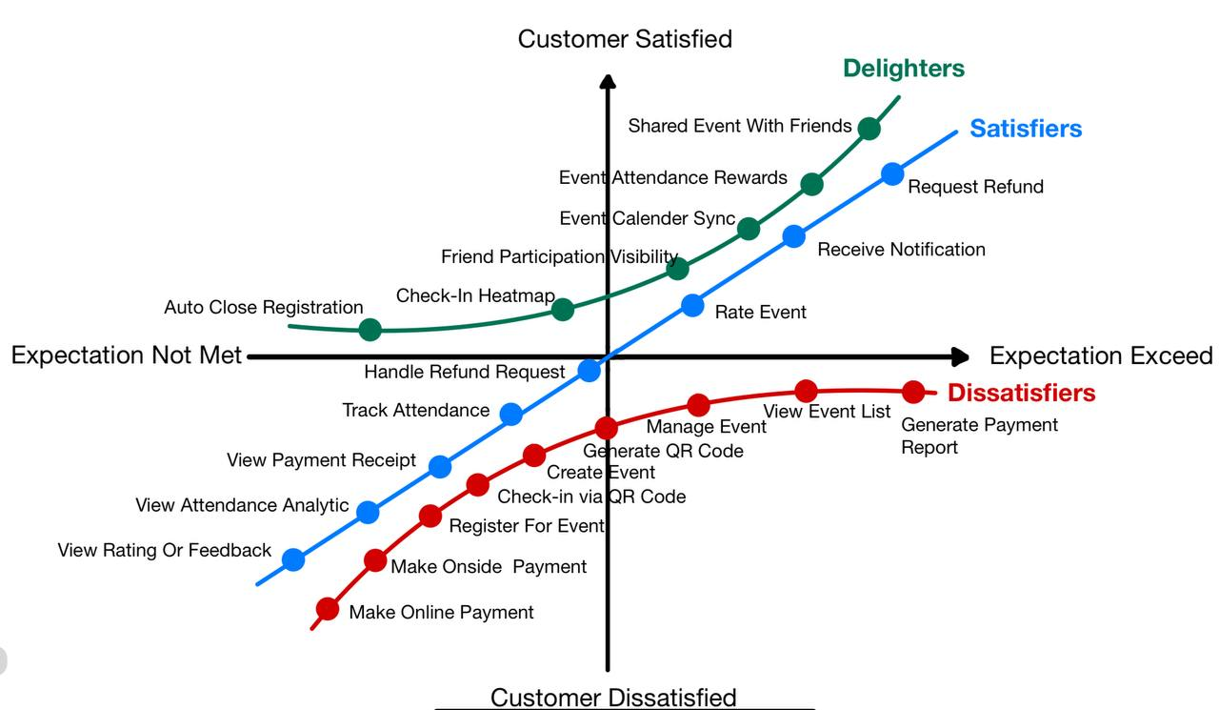

**Figure 3.3 : Kano Model Plan**

**Table 3.3 : Kano Model Plan**

| **Requirement** | **Kano Category** | **Elicitation Method** | **Description** | **User Type** |
| --- | --- | --- | --- | --- |
| Register for Event | Dissatisfier | Prototype + Questionnaire | Allows students to register for selected campus events. | Student |
| Create Event | Dissatisfier | Prototype + Questionnaire | Enables admin to input event name, date and category. | Admin |
| Manage Event | Dissatisfier | Prototype + Questionnaire | Admin can edit or delete event details. | Admin |
| Generate QR Code | Dissatisfier | Prototype + Questionnaire | Admin generates unique QR code for check-in. | Admin |
| Check-in via QR Code | Dissatisfier | Prototype + Questionnaire | Students scan QR and verify with Name, Student ID, and Ticket ID. | Student |
| Make Online Payment | Dissatisfier | Prototype + Questionnaire | Students select FPX or TNG and complete payment. | Student |
| Make Onsite Payment | Dissatisfier | Prototype + Questionnaire | Students select to pay at the event venue. | Student |
| View Event List | Dissatisfier | Prototype + Questionnaire | Students browse available campus events. | Student |
| Generate Payment Report | Dissatisfier | Prototype + Questionnaire | Admin generates detailed reports of payments per event. | Admin |
| Track Attendance (Live) | Satisfier | Prototype + Questionnaire | Admin monitors real-time attendance logs. | Admin |
| Handle Refund Request | Satisfier | Prototype + Questionnaire | Admin views and approves or rejects student refund requests. | Admin |
| View Payment Receipt | Satisfier | Prototype + Questionnaire | Students can view proof of payment. | Student |
| View Rating or Feedback | Satisfier | Prototype + Questionnaire | Admin accesses student feedback and star ratings. | Admin |
| View Attendance Analytics | Satisfier | Prototype + Questionnaire | Admin analyzes attendance statistics by event. | Admin |
| Receive Notification | Satisfier | Prototype + Questionnaire | Students receive alerts after registration and payment. | Student |
| Request Refund | Satisfier | Prototype + Questionnaire | Students request a refund from their payment receipt. | Student |
| Rate Event | Satisfier | Prototype + Questionnaire | Students give post-event feedback and star rating. | Student |
| Shared Event with Friends | Delighter | Questionnaire | Option to share events via social media or chat apps. | Student |
| Event Attendance Rewards | Delighter | Questionnaire | Students receive points or badges for attending events. | Student |
| Friend Participation View | Delighter | Questionnaire | View which friends have registered for the same event. | Student |
| Event Calendar Sync | Delighter | Questionnaire | Sync event schedule with device calendar. | Student |
| Check-In Heatmap | Delighter | Questionnaire | Admin visualizes peak check-in times via chart. | Admin |
| Auto Close Registration | Delighter | Questionnaire | System disables event registration after deadline or when full. | Admin |

## 

## **3.4 Sample Questions**

### **3.4.1 Choose Admin or Student**

At the beginning of the questionnaire, users are asked to select their role (Student or Admin). This allows us to direct them to the relevant set of questions and collect role-specific feedback.

1.What is your role in the system?

option :

* Student
* Admin

### **3.4.2 Student Sample Questions**

These questions are tailored to students based on system features they interact with.

1. How do you feel if you can view a list of all upcoming campus events from your dashboard?

option :

* I like it
* I expect it
* I am neutral
* I can tolerate it
* I dislike it

2. How do you feel if you can register for events directly through the system?

option :

* I like it
* I expect it
* I am neutral
* I can tolerate it
* I dislike it

3. How do you feel if you cannot make online payments and must pay cash on-site?

option :

* I like it
* I expect it
* I am neutral
* I can tolerate it
* I dislike it

4. How do you feel if there is no QR code and you must manually write your name during check-in?

option :

* I like it
* I expect it
* I am neutral
* I can tolerate it
* I dislike it

5. How do you feel if you can request a refund through the system for paid events if you cannot attend the event?

option :

* I like it
* I expect it
* I am neutral
* I can tolerate it
* I dislike it

6. How do you feel if there are no payment receipts available?

option :

* I like it
* I expect it
* I am neutral
* I can tolerate it
* I dislike it

7. How do you feel if you can give ratings and feedback after an event?

option :

* I like it
* I expect it
* I am neutral
* I can tolerate it
* I dislike it

8. How do you feel if you receive no notifications at all?

option :

* I like it
* I expect it
* I am neutral
* I can tolerate it
* I dislike it

9. How do you feel if you can earn points or badges for attending events?

option :

* I like it
* I expect it
* I am neutral
* I can tolerate it
* I dislike it

10. How do you feel if you can see which of your friends (from the same university) registered for the same event?

option :

* I like it
* I expect it
* I am neutral
* I can tolerate it
* I dislike it

11. How do you feel if you can export events to your personal calendar (Google Calendar/Outlook)?

option :

* I like it
* I expect it
* I am neutral
* I can tolerate it
* I dislike it

12. How would you feel if you can share event info with your friends via social media or messaging apps?

option :

* I like it
* I expect it
* I am neutral
* I can tolerate it
* I dislike it

### 

### 

### 

### **3.4.3 Admin Sample Questions**

These questions focus on admin functionalities.

1. How do you feel if the system allows you to create events directly from your mobile device?

option :

* I like it
* I expect it
* I am neutral
* I can tolerate it
* I dislike it

2. How do you feel if the system does not generate QR codes for check-in?

option :

* I like it
* I expect it
* I am neutral
* I can tolerate it
* I dislike it

3. How do you feel if you can view real-time attendance during an event?

option :

* I like it
* I expect it
* I am neutral
* I can tolerate it
* I dislike it

4. How do you feel if you can view student ratings and feedback after the event?

option :

* I like it
* I expect it
* I am neutral
* I can tolerate it
* I dislike it

5. How do you feel if you can view and approve refund requests from the app?

option :

* I like it
* I expect it
* I am neutral
* I can tolerate it
* I dislike it

6. How do you feel if the system does not generate financial reports?

option :

* I like it
* I expect it
* I am neutral
* I can tolerate it
* I dislike it

7. How would you feel if the system could automatically close event registration once the limit is reached?

option :

* I like it
* I expect it
* I am neutral
* I can tolerate it
* I dislike it

8. How would you feel if no heatmap or check-in trends were shown during events?

option :

* I like it
* I expect it
* I am neutral
* I can tolerate it
* I dislike it

## **3.5 Expected Outputs from Questionnaire**

### **3.5.1 Categorized User Requirements**

* All user responses collected through the questionnaire will be analyzed and categorized using the Kano Model into the following requirement types:  
  + **Dissatisfiers:** Basic features users expect by default, such as login, event registration, and QR code check-in. If these are missing or poorly implemented, users will be dissatisfied.
  + **Satisfiers:** Performance-based features like real-time attendance tracking, receipt viewing, and refund handling. The better these are implemented, the higher the user satisfaction.
  + **Delighters:** Unexpected features that pleasantly surprise users, such as automatic event registration closure, sharing events with friends, and syncing with the user's calendar. These add satisfaction but are not expected by default.

### **3.5.2 Stakeholder-specific Needs**

* The results will be organized by stakeholder groups to ensure all perspectives are addressed:  
  + **Students:** Insights into how they register for events, prefer to pay (FPX/TNG/On-site), receive notifications, and give feedback.
  + **Admins (Event Organizers):** Needs related to creating and managing events, generating QR codes, tracking attendance, handling refund approvals, and generating reports.
* By analyzing these responses, we will identify:  
  + Shared needs between both groups (e.g., login, payment confirmation).

# **4 Kano Model Application & Analysis Methodology**

## **4.1 Kano Model Categories**

**Table 4.1 : Kano Model Categories**

| **Kano Category** | **Identification Criteria** | **Example Features**  **(Based on CECS)** |
| --- | --- | --- |
| **Dissatisfier** | * Fundamental features that users naturally expect to be present. * If these are missing, users will be unhappy, even though having them doesn’t create extra satisfaction. | * Login * QR Code Check-in * Event Registration |
| **Satisfier** | * Functionalities that users specifically look for and expect to work efficiently. * The better these are implemented, the more users appreciate them; if handled poorly, it leads to dissatisfaction. | * Real-time Attendance Tracking * Refund Handling * Receipt Viewing |
| **Delighter** | * Value-added features that are not anticipated but pleasantly surprise users. * Their inclusion boosts satisfaction, but users won’t feel disappointed if they’re not available. | * Auto-close Event Registration * Share Event with Friends * Event Calendar Sync |

## 

## 

## 

## **4.2 Analysis Methodology**

In this project, we decided to use two main methods to collect and understand user needs: prototyping and questionnaires based on the Kano model. The main reason for choosing these two methods is that they can help us effectively identify user needs and understand the importance of these features to the overall experience of the campus event check-in system.

We started with prototyping to visualize the potential functionality of the system. This allowed us to explore user flows, identify potential pain points, and refine our solutions based on initial feedback. Prototyping helped the team start talking and sharing ideas. It made it easier for everyone to agree on what the main features should be and what kind of experience we wanted for users.

Following this, we employed a Kano-based questionnaire to validate and classify the features identified during the prototyping phase. The questionnaire was distributed to key user groups, including students and some event organizers, asking them to rate their satisfaction with or without specific features. Based on the results, we categorized the features into three groups: Dissatisfiers (basic features that users expect and require), Satisfiers (features that improve user satisfaction when done well), and Delighters (unexpected features that provide a pleasant surprise).

The final result is a detailed classification of requirements that clearly outlines which features are essential must-haves, which improve the experience, and which add extra value. This foundation will guide the development of the campus event check-in system to ensure it effectively meets user needs and delivers a smooth, enjoyable experience for all involved.

# 

# 

# 

# **5 Timeline and Milestones**

**Table 5.1 : Timeline and Milestones**

| **Milestone** | **Activities** | **Date** | **Location** | **Deliverable** | **Involve Members** |
| --- | --- | --- | --- | --- | --- |
| Planning Completion | Finalize plan and contribution of each members | 1 May 2025 | Online Meeting - Microsoft Teams | Requirements Elicitation Plan document | All team members |
| Requirement Gathering | Categorize requirements using Kano Model | 3 May 2025 | Online Meeting - Microsoft Teams | Requirement Summary & Categorization | All team members |
| Prototype Planning | Define features, user roles, and screen flow | 5 May 2025 | Online Meeting - Microsoft Teams | Feature List, Use Case Diagram, Screen Map | All team members |
| Prototype Building | Develop high- fidelity interactive prototype (clickable mockup) | 5-13  May 2025 | Figma/Online Meeting - Microsoft Teams | Interactive prototype link or file | All team members |
| Questionnaire Development | Create questionnaire | 15-18 May 2025 | Online Meeting - Microsoft Teams | Finalize Kano Model for questionnaire | All team members |
| Data Collection | Distribute and gather responses from questionnaires | 19 May 2025 | Online Google Form | Collected response data | All team members |
| Requirement Analysis | Review and analyze collected data | 20 May 2025 | Online Meeting - Microsoft Teams | Categorized Requirements Document | All team members |
| Final Documentation | Finalize system functionalities, prototype visuals, and feedback summary | 21-24 May 2025 | Online Meeting - Microsoft Teams | Final project report PDF | All team members |

## 

## 

# **6 Expected Outputs Summary**

From the requirement elicitation activities conducted through prototype and the ongoing questionnaire process, we expect to collect a well-structured set of system features that reflect the real needs of students and administrators. These features will be categorized using the Kano Model into dissatisfiers, satisfiers, and delighters to distinguish which functions are essential, which enhance user satisfaction, and which offer additional value.

The feedback will help us figure out the main features like signing up for events, handling payments, checking in with QR codes, and managing refunds. It’ll also show us new ideas like giving out rewards for participation, syncing with calendars, and seeing where most people attend. These insights will allow us to prioritize features based on stakeholder expectations and usage patterns.

Ultimately, the findings from these elicitation tasks will contribute directly to the development of a complete and accurate Software Requirements Specification (SRS). This ensures the system design is guided by user-centered requirements and results in a solution that is both functional and well-aligned with user expectations.